Contents

1. Description of the project 2

1.1 Goal 2

1.2 Product 2

1.3 Process 3

2. Product History 4

2.1 Release 4

2.2 Adoption 4

2.3 Feature Tracking 4

2.4 Critical Reviews 4

3. Product Structure 4

3.1 Architecture 4

3.2 Design 4

3.3 Code-base 4

3.4 Documentation 4

3.5 Test 5

4. Defect Management 5

4.1 Report 5

4.2 Repair 5

4.3 Release 5

5. Appraisal of the Product and Management 5

5.1 Standards Compliance 5

5.2 Maintainability 5

5.3 Reliability 5

5.4 Usability 5

5.5 Extensibility 5

5.6 Portability 5

# Description of the project

## Goal

BroadleafCommerce is an open-source, e-commerce framework written entirely in Java on top of the Spring framework. It is targeted at facilitating the development of enterprise-class, commerce-driven sites by providing a robust data model, services and specialized tooling that take care of most of the "heavy lifting" work. To accomplish this goal, we have developed our platform based on the key feature sets required by world-class online retailers - and we're committed to continually expanding our feature offering. We've also taken extra steps to guarantee interoperability with today's enterprise by utilizing standards wherever possible and incorporating best-of-breed, open-source software libraries from the community.

## Product

Product List:

|  |  |
| --- | --- |
| Item | Description |
| blc-authorizenet | Broadleaf Authorize.net Integration Module (Direct Post Method) |
| docs | The new Broadleaf wiki |
| Menu | Broadleaf Commerce currently offers a community abstraction Menu module that allows managing Categories and Site Navigation in terms of Menus in the Admin much easier. |
| Demo Site | The New Broadleaf Commerce Demo Site |
| BroadleafCommerce | Main Project |
| [blc-amazon](https://github.com/BroadleafCommerce/blc-amazon) | Integration of BLC and Amazon services. |
| [copy-github-labels](https://github.com/BroadleafCommerce/copy-github-labels) | Easily copy GitHub labels from one repository to another. Uses [GitHub API for Node.js](https://github.com/mikedeboer/node-github). |
| [blc-paypal](https://github.com/BroadleafCommerce/blc-paypal) | Broadleaf PayPal Integration Module (Express Checkout) |
| [ansible](https://github.com/BroadleafCommerce/ansible) | Ansible is a radically simple IT orchestration engine that makes your applications and systems easier to deploy. Avoid writing scripts or custom code to deploy and update your applications— automate in a language that approaches plain English, using SSH, with no agents to install on remote systems. |
| [ModuleTemplate](https://github.com/BroadleafCommerce/ModuleTemplate) | A template project for creating Broadleaf modules |
| [BasicInventory](https://github.com/BroadleafCommerce/BasicInventory) | Basic inventory module |
| [CatalogMetaData](https://github.com/BroadleafCommerce/CatalogMetaData) | Broadleaf MetaData Module. |
| [blc-usps](https://github.com/BroadleafCommerce/blc-usps) | Broadleaf USPS Integration Module |
| [blc-cybersource](https://github.com/BroadleafCommerce/blc-cybersource) | Broadleaf CyberSource Integration Module |
| [I18n](https://github.com/BroadleafCommerce/I18n) | Internationalization Extension Module |
| [AdminLanguagePack](https://github.com/BroadleafCommerce/AdminLanguagePack) | Project to hold Admin locale specific property files |
| [MavenArchetypes](https://github.com/BroadleafCommerce/MavenArchetypes) | Maven archetypes for jump starting a Broadleaf Commerce implementation |
| [GrailsPlugin](https://github.com/BroadleafCommerce/GrailsPlugin) | broadleaf-grails-plugin |

Main Project:

Use-case Diagram Customer:

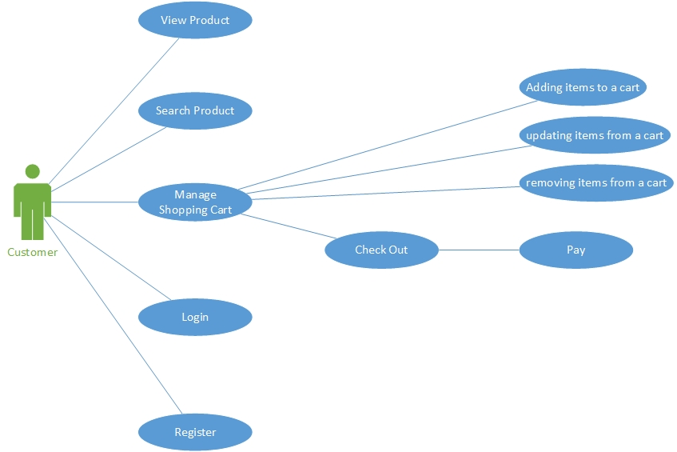

Use-case Diagram Admin:

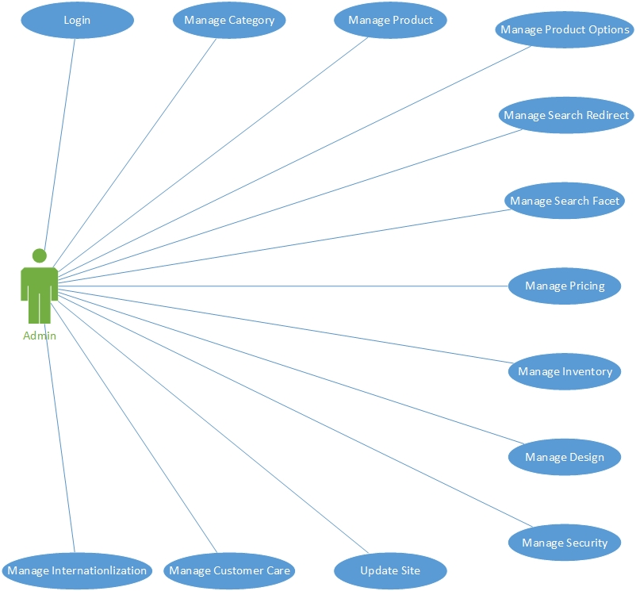

<http://www.broadleafcommerce.com/features#cartAndCheckout>

<https://www.youtube.com/watch?v=1xVF8xIrbcI>

<https://www.youtube.com/watch?v=EiuY3bzzVbw&feature=youtu.be>

## Process

Agile Scrum:

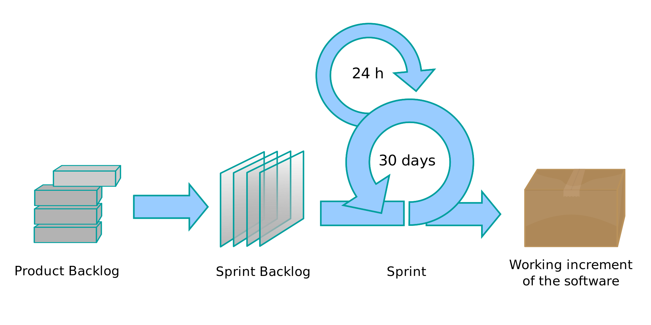

Evidence:

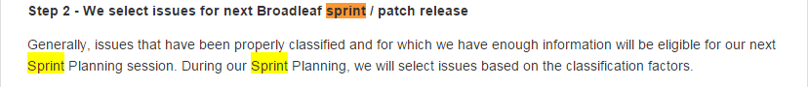

Hyperlink: https://github.com/BroadleafCommerce/BroadleafCommerce/blob/BroadleafCommerce-4.0.x/CONTRIBUTING.md

# Product History

## Release

Motivation of changes

Bug fixing

Fix logging in PaymentGatewayAbstractController #1017

perfective

Better i18N AddressImpl compatibility #775

Adaptive

Update to the latest Spring 4.1 version #1116

Feature enhancement

Add Account Domain to framework #1166

## Adoption

## Feature Tracking

## Critical Reviews

# Product Structure

## Architecture

## Design

## Code-base

## Documentation

Document List:

|  |  |
| --- | --- |
| Item | Description |
| Getting Started | Getting environment up and running, show where things live, and walk through a few examples. |
| Broadleaf Concepts | This section is where the majority of information on Broadleaf functionality and concepts can be found. We describe how important operations such as cart modification, pricing, and payment occur as well as additional configuration that Broadleaf supports. |
| Modules | Broadleaf Commerce can be enhanced with add-on modules. |
| Tutorials | This tutorial section will walk you through examples start to finish that demonstrate how to work with various different parts of Broadleaf Commerce. |
| Database Model | Model Changes and current ER Diagram |
| Release Notes | The note of release, including description, bugs, and enhancements. |
| Migration Notes | This section contains migration documents that will help developer transition his current Broadleaf installation to a more recent version. |
| Appendix | Other documents which are associated with the project. |
| Javadocs | Javadocs including Package, Class, Use, Tree, Deprecated, Index, and Help. |

This Project provide pretty good documents for using. But no document for introducing the develop process.

## Test

# Defect Management

## Report

## Repair

## Release

# Appraisal of the Product and Management

## Standards Compliance

## Maintainability

## Reliability

## Usability

## Extensibility

## Portability